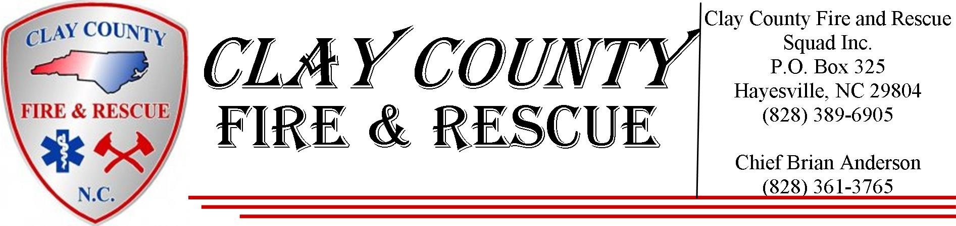
Membership Application

Dear Applicant,

Thank you for your interest in Clay County Fire and Rescue Squad Inc. Any person of good Character may apply for membership in the department. Application for membership shall be approved by the general members in attendance at any duly authorized meeting. Also please review the following application packet carefully before returning.

In order to be considered, please attach the following additional materials:

- A copy of your North Carolina Driver’s License
  - A copy of your Criminal record ran through the national data base done by the Clay County Sheriff’s Office. After submitting an application, a date will be set up by the Chief for you to go get finger printed to allow the back ground check to be performed. This article is not needed if you are applying as a Junior Member
- Copies of emergency services certifications you currently hold.

Consideration of applications will base on the following priorities:

- North Carolina Firefighter and Emergency Medical certification
- North Carolina Emergency Medical Training
- North Carolina Technical Rescuer Training
- Previous Experience with another Emergency Service Agency
- No Experience

Applicant must meet the following criteria in order to be considered for membership:

- Must be 18 years or older, unless applying for junior membership.
- Must not have had more than 3 Moving violations within the past 2 years.
    - Must list ANY felony or misdemeanor convictions.
- Must list ANY DUI convictions. These will be reviewed on a case-by-case basis.
- Must have a valid North Carolina Driver’s License.
- Must be in good physical condition.

Clay County Fire and Rescue
Membership Application – Personal Information

Name: |  |  |  |  |  |  |  |  |  |  |  |  |  |  |  |  |  |  |  |  | SSN:
Last First Mi
Address:
Street
City State Zip
Home Phone: |  |  |  |  |  |  |  |  |  |  |  |  |  |  | Cell Phone:
Other Phone: |  |  |  |  |  |  |  |  |  |  |  |  |  |  | Date of Birth:
Driver’s License No.: |  |  |  |  |  |  |  |  |  |  | State: |  |  |  |  |  |  |  |  |  |  | Class: |  |  |  |  |  |  |  | Exp:
Marital Status: |  |  |  |  |  |  |  |  |  |  |  |  | Spouse’s Name:
Emergency Contact: |  |  |  |  |  |  |  |  |  |  |  |  |  |  |  |  |  |  |  | Contact No.:
Present Employer: |  |  |  |  |  |  |  |  |  |  |  |  |  |  |  |  | May We Contact Them: |  |  |  |  |  |  |  |  | Yes No
Dependent’s Names:
List any physical limitations:
List any health problems:
Education
Are you a High School Graduate: |  |  |  |  |  |  |  | Yes No |  |  |  |  |  | If no, do you have a GED? |  |  |  |  |  |  |  |  |  |  |  |  |  |  | Yes No
School |  |  | Name and Location |  |  |  |  |  |  |  |  |  | Course of Study |  |  |  |  |  |  |  |  |  | Completed |  |  |  |  | Type of Degree
High School |  |  |  |  |  |  |  |  |  |  |  |  |  |  |  |  |  |  |  |  |  |  | 9 10 11 12
Tech School |  |  |  |  |  |  |  |  |  |  |  |  |  |  |  |  |  |  |  |  |  |  | 1 2 3 4
College |  |  |  |  |  |  |  |  |  |  |  |  |  |  |  |  |  |  |  |  |  |  | 1 2 3 4

Personal References
Please list 3 individuals that are neither related to, nor living with you. You should have known the individual for at least 2 years.
Name: | Address: |  |  |  | Phone:
Please list two people that are members of Clay County Fire and Rescue that you have known for at least one year.
Name: | Phone: |  |  |  | Rank:
Criminal History
Have you incurred any traffic charges within the past 3 years? If yes, please provide details: |  |  |  | Yes No
Date Charge |  | Date Charge
Have you been charged or convicted with a DUI conviction in the past 5 years? |  |  | Yes No
Have you had more than 3 moving violations in the past 2 years? |  |  | Yes No
Have you ever been convicted of a Felony or Misdemeanor? |  |  | Yes No
Where Charge |  | Where Charge

Skills and Training
Have you completed NFPA 1403? If ‘Yes’, please submit proof. |  |  |  |  |  |  |  |  |  |  | Yes No
Are you North Carolina Firefighter certified? If ‘Yes’, please submit proof. |  |  |  |  |  |  |  |  |  |  | Yes No
Are you a North Carolina certified or Nationally Registered EMT?  If ‘Yes’, please submit proof of level. |  |  |  |  |  |  |  |  |  |  | Yes No
Are you North Carolina certified in any Technical Rescue specialty?  If ‘Yes’, please submit proof of level. |  |  |  |  |  |  |  |  |  |  | Yes No
Please list any training or certifications you have that maybe beneficial to this agency
Have you ever been a member of another fire, rescue, or similar organization? |  |  |  |  |  |  |  |  |  |  | Yes No
Name of organization:
Dates of Service: |  |  |  |  | Position Held:
Address of Agency:
Street City State Zip
Agency Phone: |  |  |  |  | Agency Fax:
Commanding Officer: |  |  |  |  |  |  | Phone:
Reason for leaving:
Do you have any factors that could restrict your participation in firefighting, rescue, or emergency medical activities, training, and duties or anything that would limit your abilities to being away at night or being on call day and/or night? |  |  |  |  |  |  |  |  |  |  | Yes No
If “Yes”, please list below:

Application Statement

I certify that the information given in this application is true and completed to the best of my ability. I understand that this application is not a contract of membership. I understand that any untrue statement in this application may result in my dismissal at any time during membership with Clay County Fire and Rescue Squad, Inc.

I authorize the release of high school and college transcripts, information concerning my employment, information regarding membership with another organization, as well as any other information that may be pertinent to the application and application procedures of Clay County Fire and Rescue Squad, Inc. Furthermore, I release all parties from liability for any damage that may result from requesting, providing, processing, retaining, or releasing any information about myself. A photographic copy of this agreement shall be as valid as the original.

I, (fill in name), understand that I am required by Clay County Fire and Rescue Squad, Inc. to undergo a 6-month probationary period and will not be issued any equipment during that probationary period unless authorized by the Chief, or Assistant Chief(s). I also understand that during my probationary period, I may be terminated for any infraction and that I am required to abide by the organizations By-Laws, By-Law amendments, and Standard Operating Guidelines.

Furthermore, I understand that I am required by Clay County Fire and Rescue Squad, Inc. to obtain thirty-six hours of training or more per year. I also understand that after one year, if I have not obtained thirty-six hours of training, I may be terminated and give up all my privileges with Clay County Fire and Rescue Squad, Inc.

I understand by signing this application, I hereby acknowledge that I understand and agree to all provisions outlined Herein.

Signature |  | Date
Printed Name

